**Project Design Phase-II**

**Technology Stack (Architecture & Stack)**

|  |  |
| --- | --- |
| Date | 31 October 2022 |
| Team ID | PNT2022TMID40687 |
| Project Name | Exploratory Analysis of Rainfall Data in India for Agriculture |
| Maximum Marks | 4 Marks |

**Technical Architecture:**

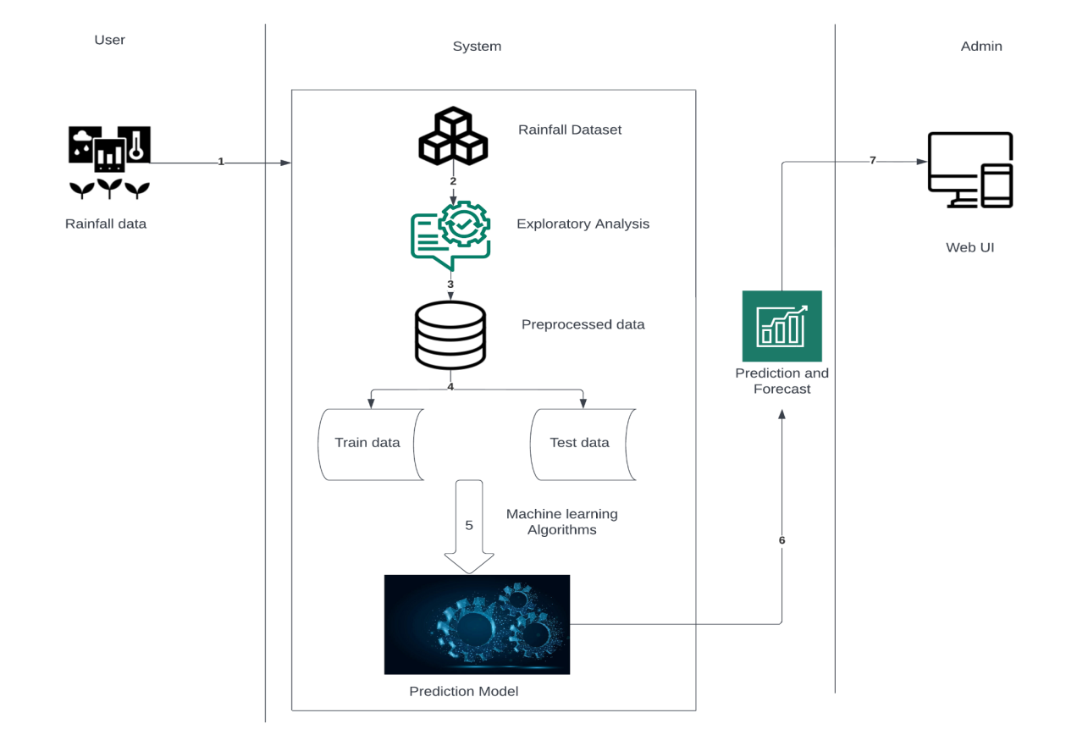

**Table-1 : Components & Technologies:**

|  |  |  |  |
| --- | --- | --- | --- |
| **S.No** | **Component** | **Description** | **Technology** |
| 1. | User Interface | The user interacts with the application through a web UI and a chatbot | HTML, CSS, python, Flask |
| 2. | Application Logic-1 | Logic for registration Registration | Python |
| 3. | Application Logic-2 | Logic for login to the application | Python |
| 4. | Application Logic-3 | Integrating machine learning model and the webpage | Flask |
| 5. | Database | Numeric data | MySQL |
| 6. | File Storage | To store files such as prediction report | Local Filesystem |
| 7. | External API | Allows developers access to critical forecasts, alerts, and observations, along with other weather data. | IBM Weather API |
| 8. | Machine Learning Model | Predictive modeling is a statistical technique using machine learning and data mining to predict and forecast likely future outcomes with the aid of historical and existing data | Predictive modeling |
| 9. | Infrastructure (Server) | Application Deployment on Local System Local Server Configuration: built-in flask web server | Flask web server |

**Table-2: Application Characteristics:**

|  |  |  |  |
| --- | --- | --- | --- |
| **S.No** | **Characteristics** | **Description** | **Technology** |
| 1. | Open-Source Frameworks | Flask | Micro web framework written in Python |
| 2. | Security Implementations | Basic HTTP authentication, Session based authentication, User Registration, Login Tracking | Flask Security |
| 3. | Scalable Architecture | Size is everything, and Flask’s status as a microframework means that you can use it to grow a tech project such as a web app incredibly quickly. Its simplicity of use and few dependencies enable it to run smoothly even as it scales up and up. | Flask |
| 4. | Availability | Higher compatibility with latest technologies and allows customization | Flask |
| 5. | Performance | * Integrated support for unit testing. * RESTful request dispatching. * Uses Jinja templating. * Support for secure cookies (client side sessions) * 100% WSGI 1.0 compliant. | Flask |